**TASK 1:**

#include<stdio.h>

int main(){

int num;

scanf("%d", &num);

if(num%3 == 0){

printf("Multiple of three");

}

else{

printf("Not a Multiple of three");

}

}

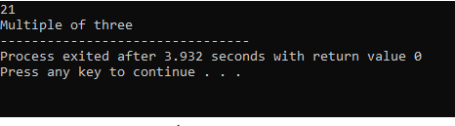

**TASK 2:**

#include<stdio.h>

int main(){

char op;

int n1, n2;

printf("Enter Operation (+, -, *, /) : ");

scanf("%c", &op);

printf("Enter number 1: ");

scanf("%d", &n1);

printf("Enter number 2: ");

scanf("%d", &n2);

switch(op){

case '+':

printf("Sum = %d", n1 + n2);

break;

case '-':

printf("Difference = %d", n1 - n2);

break;

case '*':

printf("Product = %d", n1 * n2);

break;

case '/':

printf("Division = %d", n1 / n2);

break;

default:

printf("Enter a valid operation");

break;

}

}

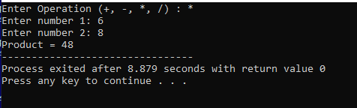

**TASK 3**

#include<stdio.h>

int main(){

char c;

printf("Enter a character : ");

scanf("%c", &c);

printf("ASCII value of character is %d \n", c);

if(c >= 65 && c <= 90){

printf("Capital alphabet");

}

else if(c >= 97 && c <= 122){

printf("Small alphabet");

}

else if(c >= 48 && c <= 57){

printf("Numeric Value");

}

else if(c >= 32 && c <= 127){

printf("Special character");

}

else{

printf("Not a valid character");

}

}

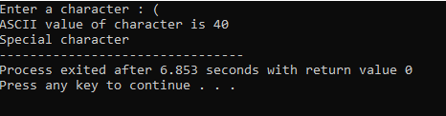

**TASK 4:**

#include<stdio.h>

int main(){

float amount;

float discount_p, discount;

float remaining;

printf("Enter your amount : ");

scanf("%f", &amount);

if(amount < 500){

printf("Not eligible");

}

else if(amount < 2000){

printf("5%% discount");

discount_p = 5;

}

else if(amount < 4000){

printf("10%% discount");

discount_p = 10;

}

else if(amount < 6000){

printf("10%% discount");

discount_p = 20;

}

else{

printf("35%% discount");

discount_p = 35;

}

discount = (discount_p/100) * amount;

printf("\n Discounted amount %.2f", discount);

remaining = amount - discount;

printf("\n Total remaining %f.2", remaining);

}

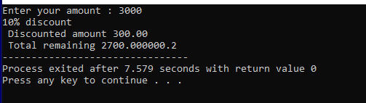

**TASK 5:**

#include <stdio.h>

int main() {

int customer_id;

char customer_name;

float units_consumed, total_amount;

printf("Enter Customer Name: ");

scanf("%c", &customer_name);

printf("Enter Customer ID: ");

scanf("%d", &customer_id);

printf("Enter Units Consumed: ");

scanf("%f", &units_consumed);

if (units_consumed <= 199) {

total_amount = units_consumed * 16.20;

} else if (units_consumed >= 200 && units_consumed < 300) {

total_amount = units_consumed * 20.10;

} else if (units_consumed >= 300 && units_consumed < 500) {

total_amount = units_consumed * 27.10;

} else {

total_amount = units_consumed * 35.90;

}

if(total_amount > 18000){

printf("Surcharge of 15%% is applied.");

float Extra = total_amount * 0.15;

printf("\nElectricity Bill\n");

printf("-----------------\n");

printf("Customer ID : %d\n", customer_id);

printf("Customer Name : %c\n", customer_name);

printf("Units Consumed: %.2f\n", units_consumed);

printf("Total Amount Before surcharge : %.2f\n", total_amount);

total_amount += Extra;

printf("Total Amount after surcharge : %.2f\n", total_amount);

}

else{

printf("\nElectricity Bill\n");

printf("-----------------\n");

printf("Customer ID : %d\n", customer_id);

printf("Customer Name : %c\n", customer_name);

printf("Units Consumed: %.2f\n", units_consumed);

printf("Total Amount : %.2f\n", total_amount);

}

}

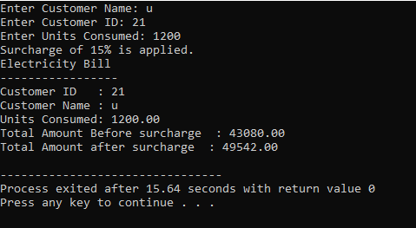

**TASK 6:**

#include <stdio.h>

int main() {

int n;

printf("Enter a positive integer: ");

scanf("%d", &n);

if (n >= 1 && n <= 9) {

switch(n) {

case 1:

printf("one\n");

break;

case 2:

printf("two\n");

break;

case 3:

printf("three\n");

break;

case 4:

printf("four\n");

break;

case 5:

printf("five\n");

break;

case 6:

printf("six\n");

break;

case 7:

printf("seven\n");

break;

case 8:

printf("eight\n");

break;

case 9:

printf("nine\n");

break;

}

} else if (n > 9) {

printf("greater than 9\n");

} else {

printf("Invalid input, please enter a positive integer.\n");

}

return 0;

}

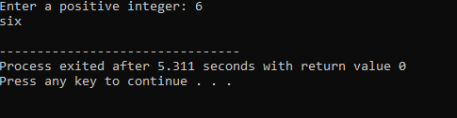

**TASK 7**

#include <stdio.h>

int main() {

int light_intensity;

printf("Enter the light sensor value (0-1000): ");

scanf("%d", &light_intensity);

if (light_intensity < 0 || light_intensity > 1000) {

printf("Invalid sensor value. Please enter a value between 0 and 1000.\n");

}

else {

if (light_intensity > 500) {

printf("Exposed under sunshine.\n");

}

else if (light_intensity >= 100 && light_intensity <= 500) {

printf("Lighting conditions.\n");

}

else if (light_intensity >= 0 && light_intensity < 100) {

printf("Evening or low light conditions.\n");

}

}

return 0;

}

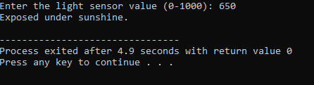

**TASK 8**

#include <stdio.h>

int main() {

int hour;

printf("Enter the time in 24-hour format (0-24): ");

scanf("%d", &hour);

if (hour >= 0 && hour <= 24) {

if (hour >= 5 && hour <= 11) {

printf("Good Morning\n");

} else if (hour >= 12 && hour <= 17) {

printf("Good Evening\n");

} else if (hour >= 18 && hour <= 24) {

printf("Good Night\n");

} else {

printf("It's late night or early morning. Get some rest!\n");

}

} else {

printf("Invalid time. Please enter a time between 0 and 24.\n");

}

return 0;

}

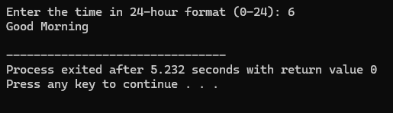

**TASK 9**

#include <stdio.h>

int main() {

float fsc_marks, nts_marks;

float fsc_percentage, nts_percentage;

printf("Enter your F.Sc. marks (out of 1100): ");

scanf("%f", &fsc_marks);

printf("Enter your NTS marks (out of 100): ");

scanf("%f", &nts_marks);

fsc_percentage = (fsc_marks / 1100) * 100;

nts_percentage = nts_marks;

printf("\nYour F.Sc. Percentage: %.2f%%", fsc_percentage);

printf("\nYour NTS Percentage: %.2f%%\n", nts_percentage);

if (fsc_percentage > 70 && nts_percentage >= 70) {

printf("You are eligible for IT in Oxford University.\n");

}

else if (fsc_percentage > 70 && nts_percentage >= 60) {

printf("You are eligible for Electronics in Oxford University.\n");

}

else if (fsc_percentage > 70 && nts_percentage >= 50) {

printf("You are eligible for Telecommunication in Oxford University.\n");

}

else if (fsc_percentage >= 60 && fsc_percentage <= 70 && nts_percentage >= 50) {

printf("You are eligible for IT in MIT.\n");

}

else if (fsc_percentage >= 50 && fsc_percentage < 60 && nts_percentage >= 50) {

printf("You are eligible for Chemical in MIT.\n");

}

else if (fsc_percentage > 40 && fsc_percentage < 50 && nts_percentage >= 50) {

printf("You are eligible for Computer in MIT.\n");

}

else {

printf("Sorry, you do not meet the criteria for Oxford University or MIT.\n");

}

return 0;

}

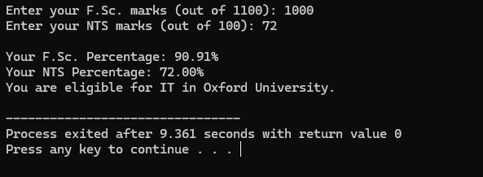

**TASK 10**

#include <stdio.h>

int main() {

float temperature;

printf("Enter the temperature: ");

scanf("%f", &temperature);

if (temperature < 0) {

printf("Freezing weather\n");

}

else if (temperature >= 0 && temperature <= 10) {

printf("Very cold weather\n");

}

else if (temperature >= 11 && temperature <= 20) {

printf("Cold weather\n");

}

else if (temperature >= 21 && temperature <= 30) {

printf("Normal temperature\n");

}

else if (temperature >= 31 && temperature < 40) {

printf("Hot weather\n");

}

else if (temperature == 40) {

printf("Very hot weather\n");

}

else {

printf("Temperature is above the defined range\n");

}

return 0;

}

